22.To design DFA of even number of a’s in automata.

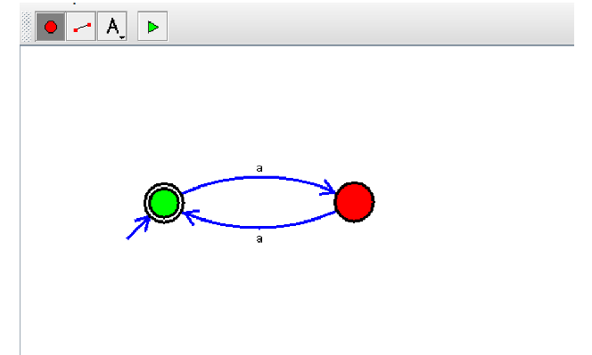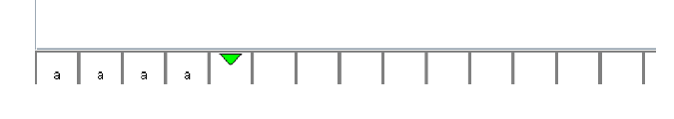

**Result:** Thus designing DFA of even number of a’s is done and verified by giving sample inputs.